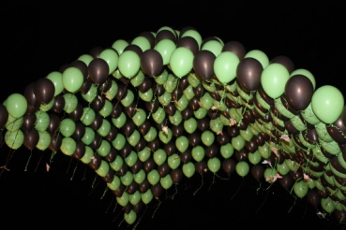
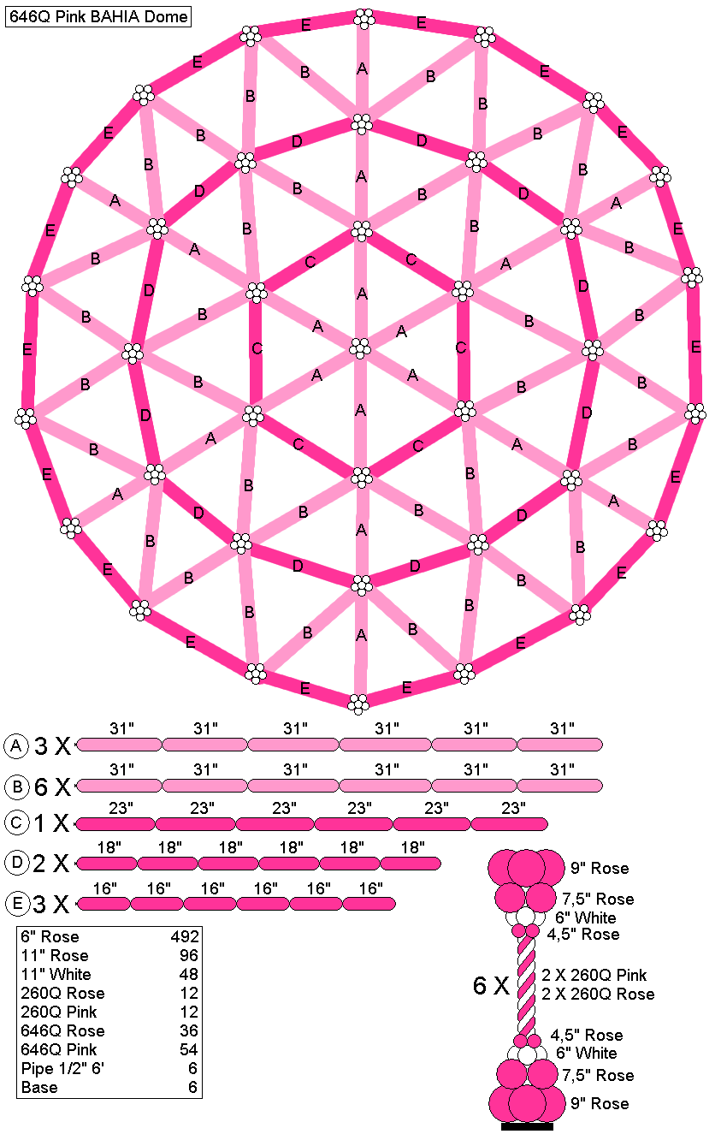
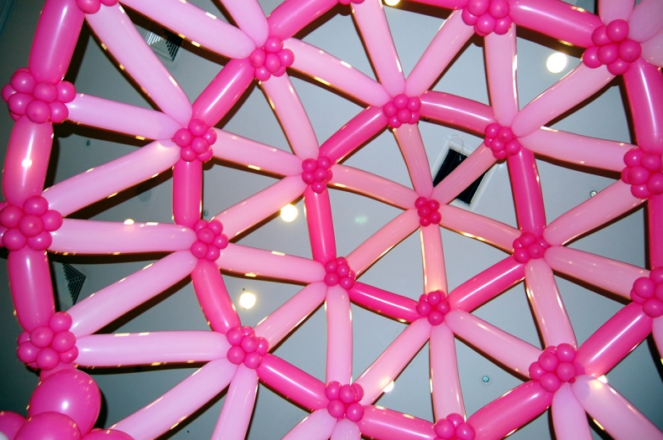
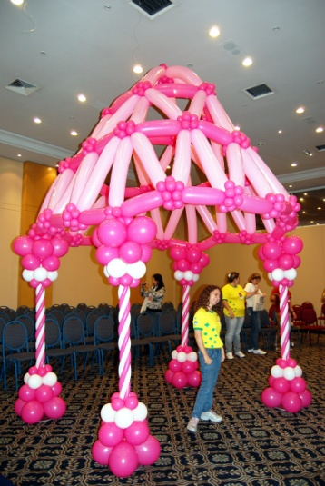
Raise the Roof with Balloons
Eduardo Seiti once again explores the limits of your imagination to create something totally new and FUN for your events. New Geodesic Dome based designs, and Simple Matrix Balloon net based canopy designs are revealed and demonstrated with some audience volunteer hands on participation welcome.

Eduardo Seiti web: ESBD.com.br

Sponsor: Silver Rainbow Co web: Silver-Rainbow.com
The first technique is for geodesic domes. This structure was invented by Richard Buckminster Füller. These domes are very strong and soft at the same time. The structure creates a dome shape of extraordinary strength to stay standing. This structure consists of bars of any material, and the dome can be made in any size. The size of their bars are calculated accordingly.
Their resistance is due to the spherical shape, and the triangles that compose its structure. Any force applied to the dome is equally distributed to its base, just like the arches in engineering and architecture.
The following images show some recipes and related dimensions we have calculated to make these specific projects work for you. With practice, you will be able to make an endless variety of your own designs to creatively and profitably meet some of your more imaginative clients needs. ENJOY!
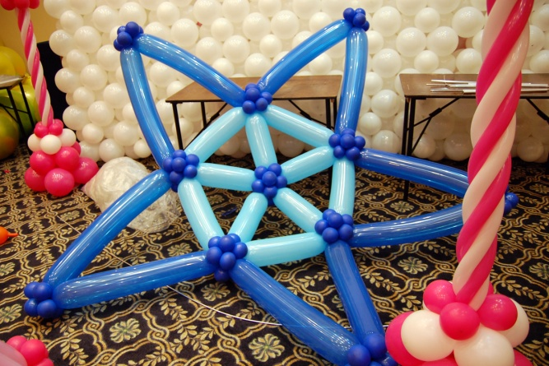
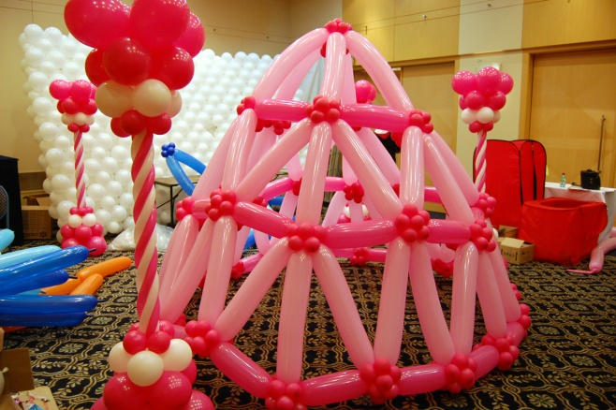
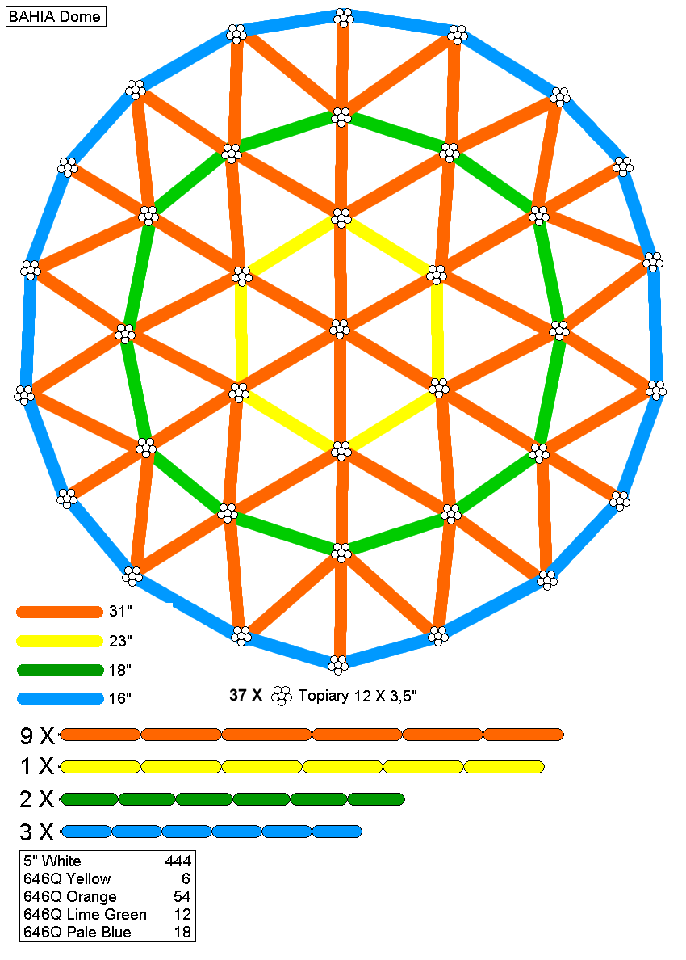
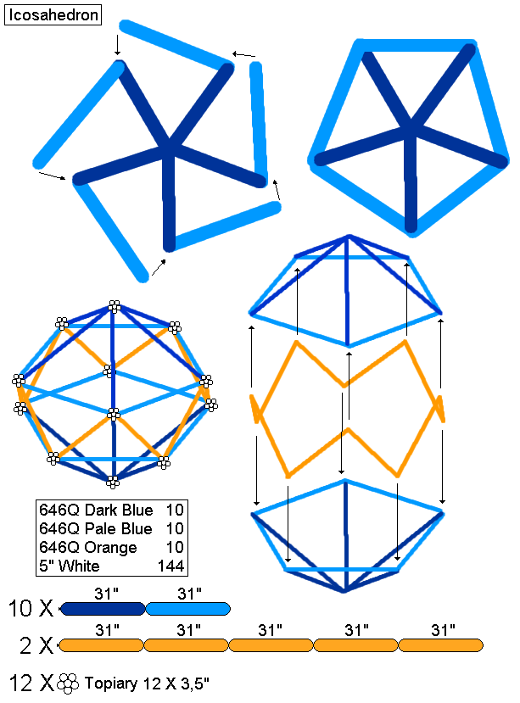
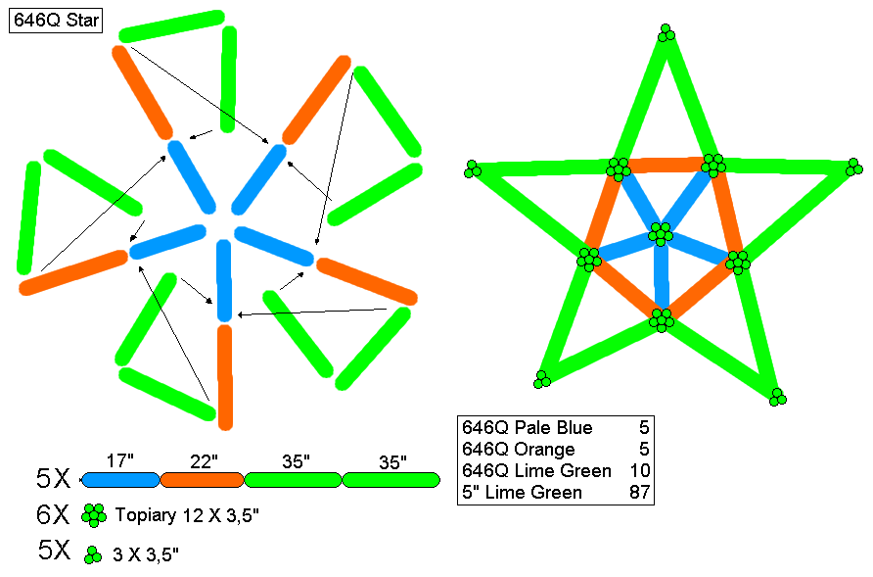
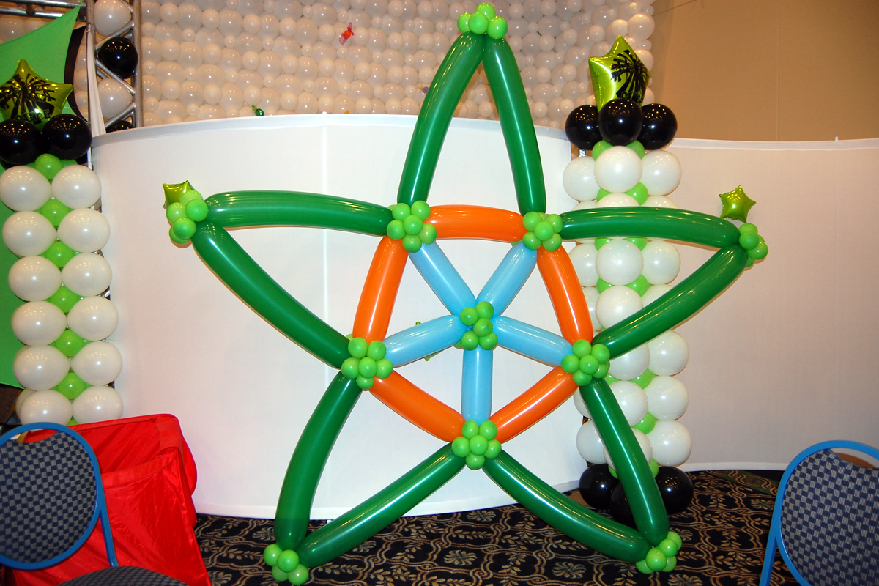

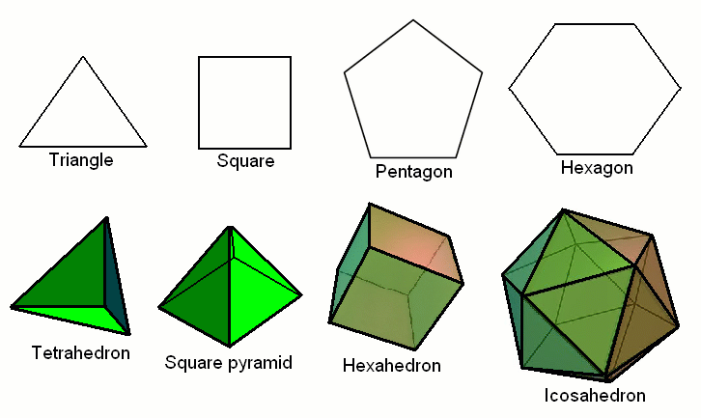
Some definitions:
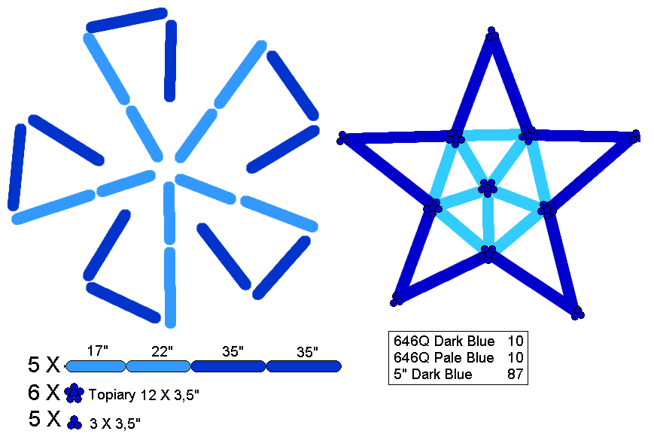
Polygon is a flat geometric figure bounded by straight lines.
Triangle is the union of three non-collinear points (belonging to a plane, due to the definition thereof) for three straight segments.
Square is a rectangle whose sides are the same length.
Hexagon is a polygon with six sides.
Pentagon is a polygon with five sides.
Tetrahedron is a geometric solid formed by four equilateral triangles
Pyramid is any polyhedron formed by a lower face and a vertex that unites all sides. Square pyramid is where the base has a quadrilateral.
Hexahedron (cube) is a polyhedron with six faces.
Polyhedron is a geometric solid whose surface is composed of a finite number of faces, where each face is a polygon. The most important elements are the faces, edges and vertices .
Icosahedron is a convex polyhedron of 20 faces.

